**Ex.No.5 Date :**

1. **Aim:** Developing use case diagram for Library Management System.

A use case diagram is a dynamic or behavior diagram in [UML.](https://www.smartdraw.com/uml-diagram/) Use case diagrams model the functionality of a system using actors and use cases. Use cases are a set of actions, services, and functions that the system needs to perform. In this context, a "system" is something being developed or operated, such as a web site. The "actors" are people or entities operating under defined roles within the system.

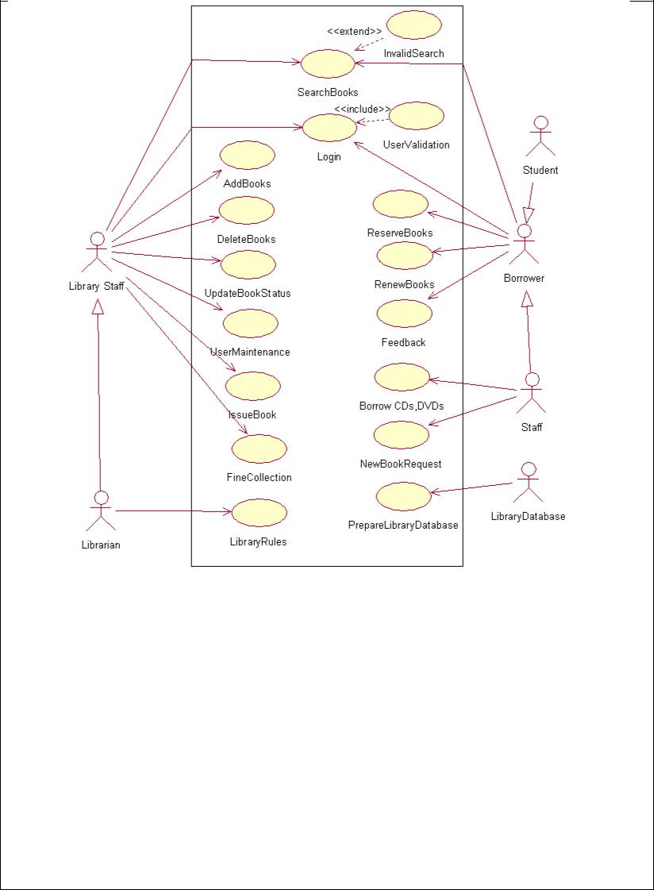

**b)** **Aim:** Developing use case description and scenario for Library Management System.

The use case scenario is a sequence of steps describing an interaction between a user and a system. The scenario must describe the following information.

Primary actors: An actor specifies a role played by a user or any other system that interacts with the subject. The primary actor of a use case is the stakeholder that calls on the system to deliver one of its services

Stakeholders and their interests: who cares about this use case, and what do they want?

Pre-conditions: Pre-conditions are tests that must prove true before the use case is allowed to proceed.

Post-conditions: Post-conditions identify the items that the use case must handle before terminating.

Main success path: Write the action steps of a scenario in which the goal is delivered. The first step is the trigger that initiates the use case. Each following step describes an action that the user or the system takes in reaction to the previous step to accomplish the use case goal.

Extensions: The extensions are the conditions that may cause the system behavior to branch from the steps that occur in the Main Success Scenario. An extension must be detectable by the system, and the system must take some action to handle it. to the success path is to be added to the scenario.

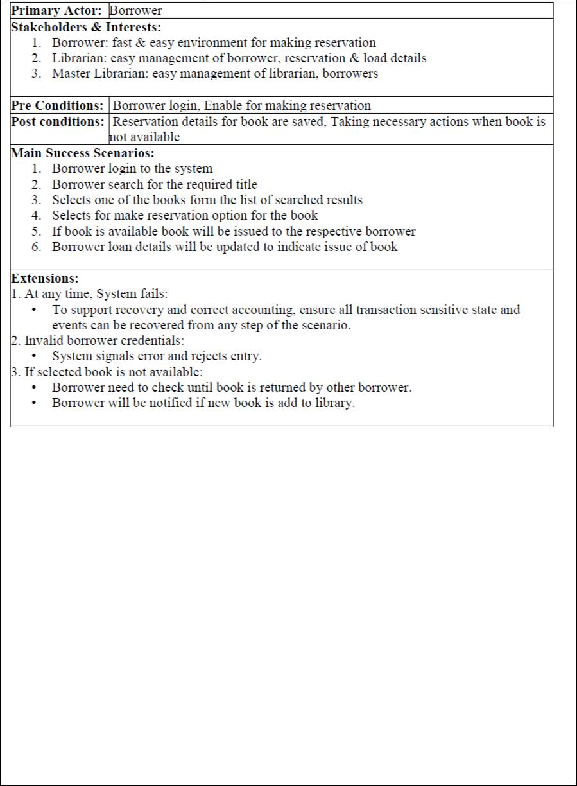

**C) Aim :** Developing prototypes for Library Management System.

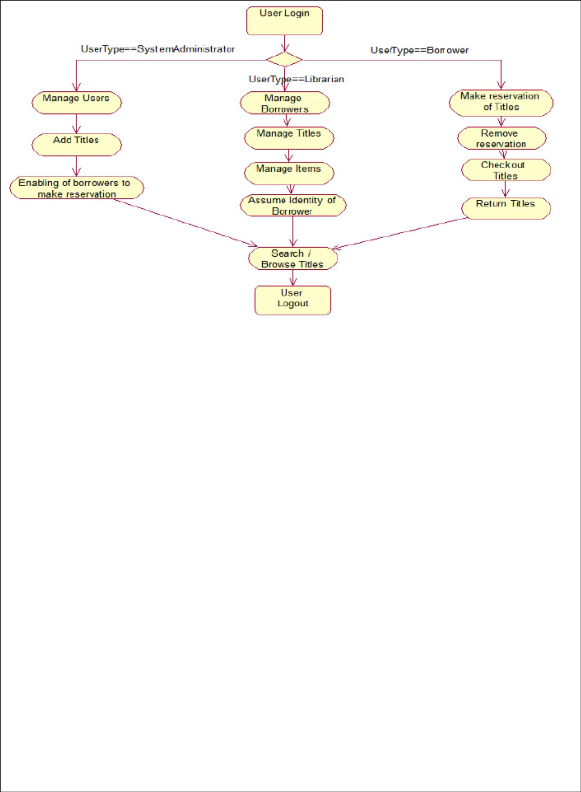A prototype is the list of activities in several paths represented based on some condition. It shows all the paths to perform a particular task based on that condition.

**d) Aim:** Developing system sequence diagrams for Library Management System.

A system sequence diagram (SSD) is a picture that shows, for a particular scenario of a use case, the events that external actors generate their order, and inter-system events. These diagrams show the details of events that are generated by actors from outside the system.The system is treated as a black-box. SSDs are derived from use cases; SSDs are often drawn for the main success scenarios of each use case and frequent or complex alternative scenarios. SSDs are used as input for object design. A system sequence diagram, including:

**Objects** - this box shape with an underlined title represents a class, or object, in UML. Withina SSD, this shape models the system as a black box.

**Actors** - shown by stick figures, actors are entities that interact with the system, and yet areexternal to it.

**Events** - the system events that the actors generate in the sequence. A dashed line, known as alifeline, represents events in an SSD. Lifelines may begin with a labeled rectangle shape or an actor symbol.



**Result:** The Design was successfully completed.



